**Superstore Sales Performance - Capstone Project**

**VIEW 1)**

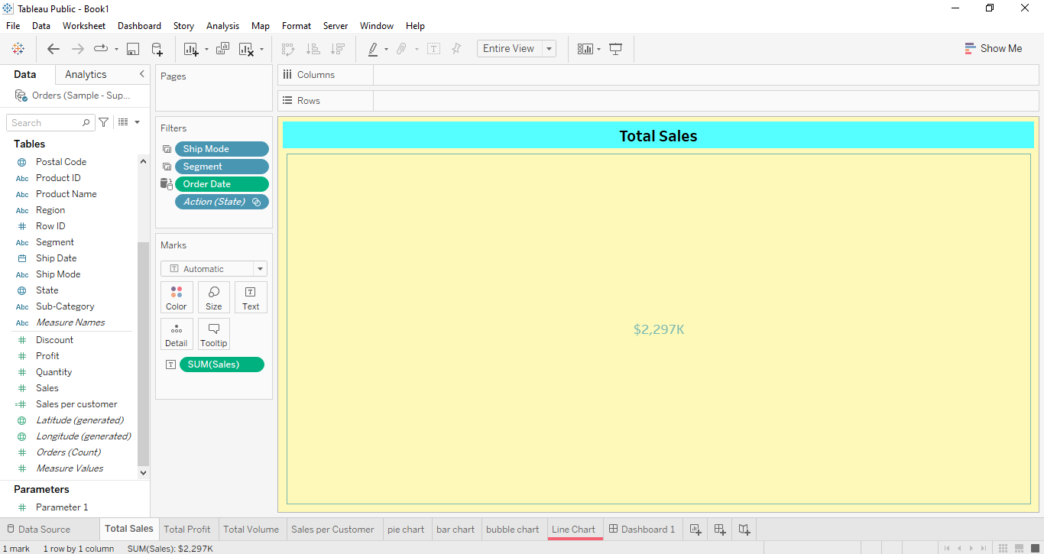

**VIEW 2)**

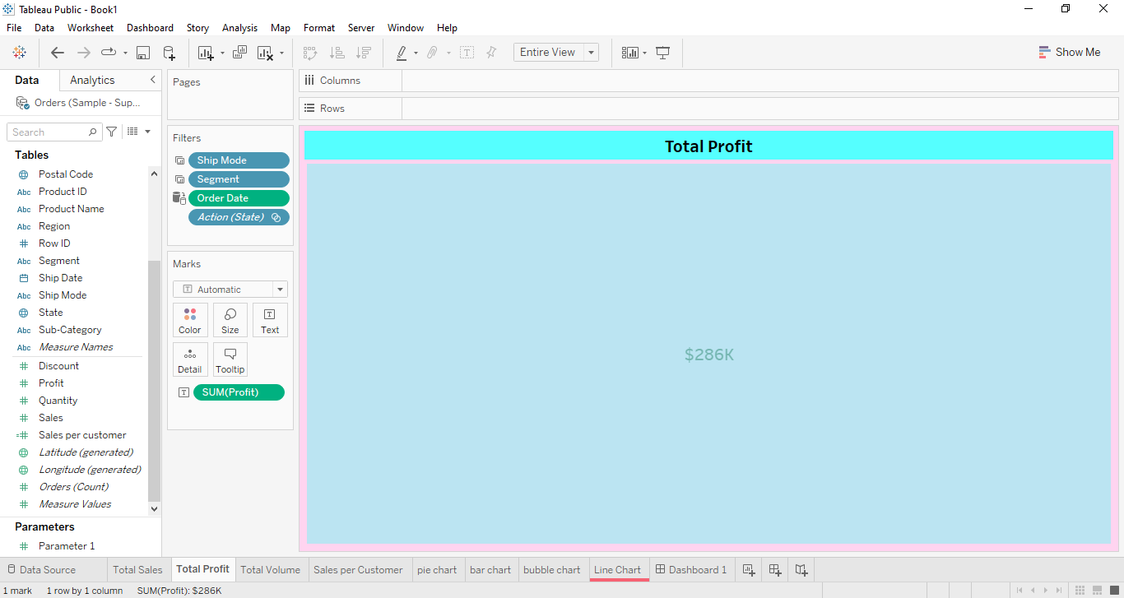

**VIEW 3)**

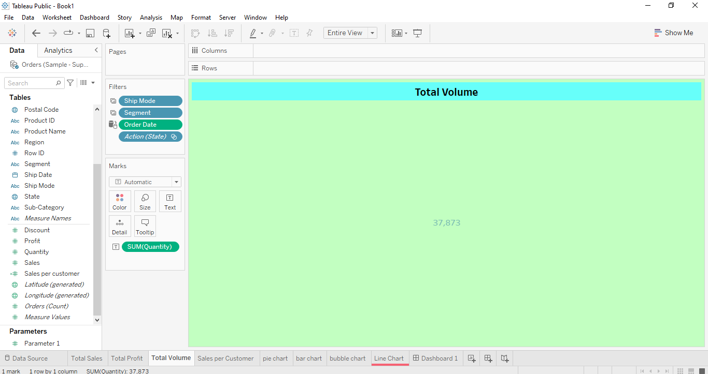

**VIEW 4)**

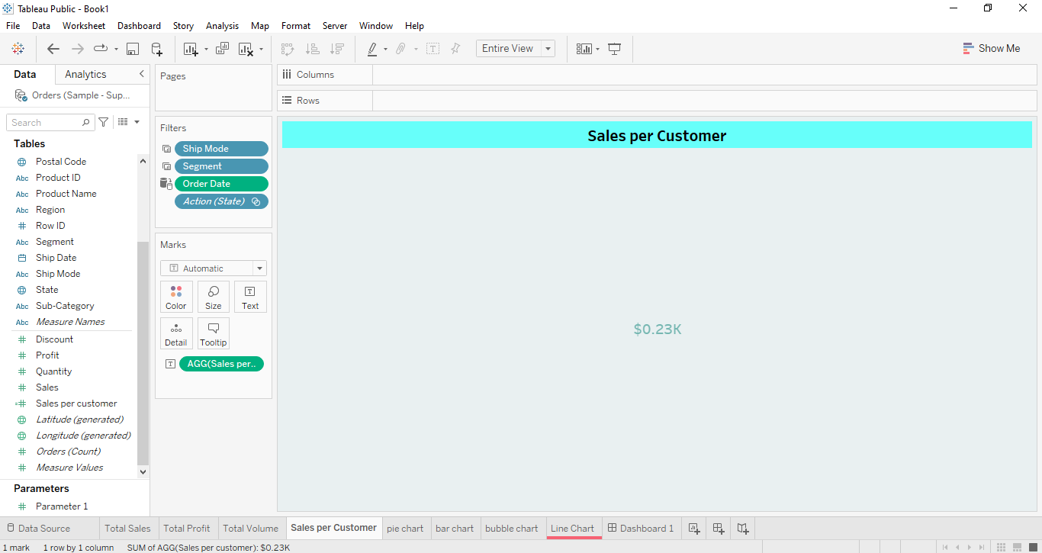

**VIEW 5)**

**VIEW 6)**

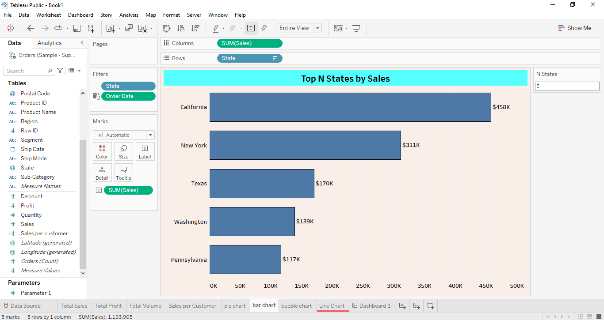

**VIEW 7)**

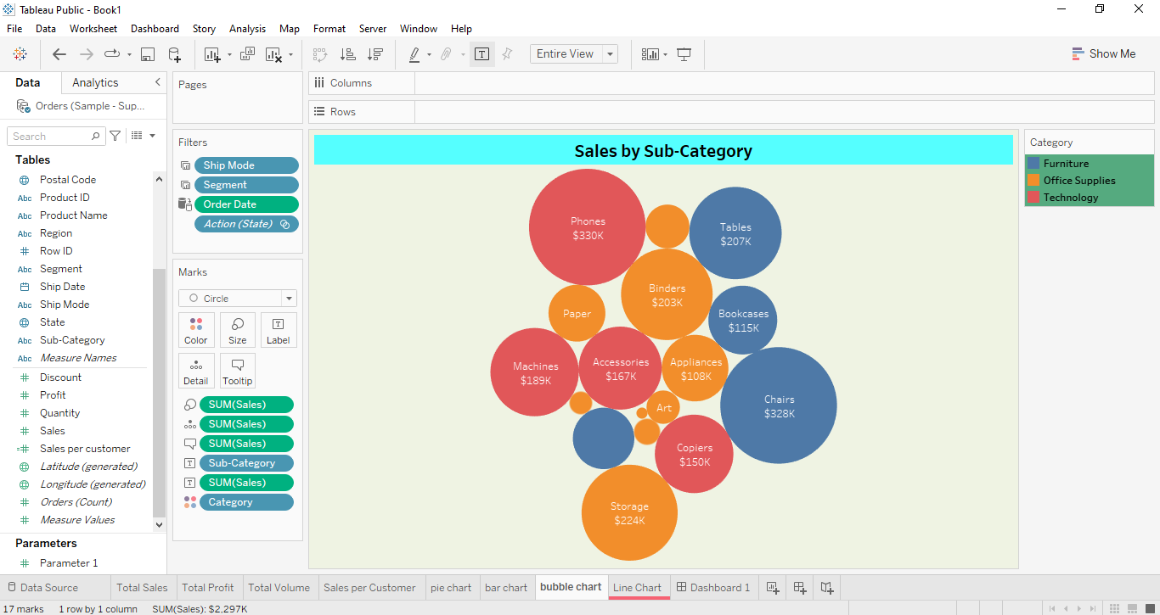

**VIEW 8)**

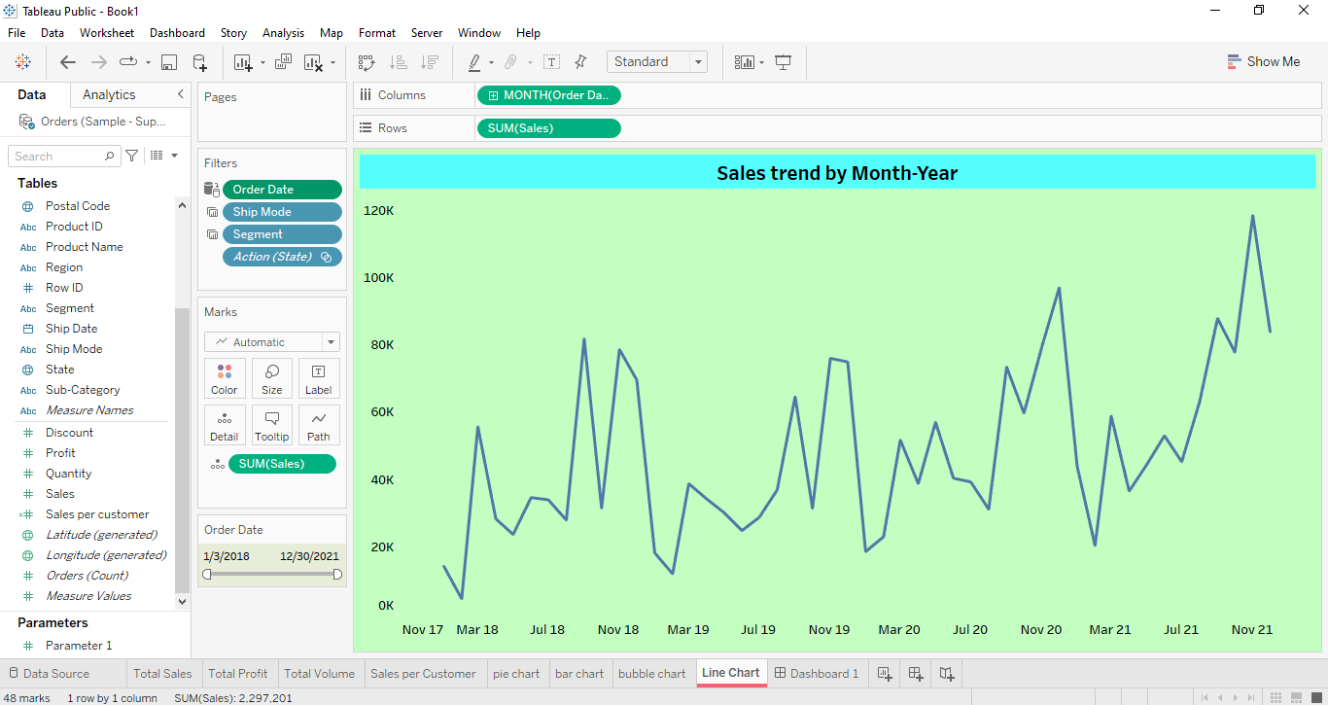

**DASHBOARD)**

